**Date:21/3/24 EXPERIMENT 10**

**Name:Rithika shree**

**21R231**

**Basics of RoS**

**Aim:**

To install the RoS Noetic version and learn to create a workspace in ROS and to run simple program.

**Software/ Package Used:**

RoS

**Programs:**

1. **Write a RoS program to configure a node and send a message and configure two different users to receive the same message.**

**PUBLISHER CODE:**

#!/usr/bin/env python3

import rospy

from std_msgs.msg import String

def talker():

pub = rospy.Publisher('chatter', String, queue_size=10)

rospy.init_node('talker', anonymous=True)

rate = rospy.Rate(10) # 10hz

while not rospy.is_shutdown():

hello_str = "hello world %s" % rospy.get_time()

rospy.loginfo(hello_str)

pub.publish(hello_str)

rate.sleep()

if __name__ == '__main__':

try:

talker()

except rospy.ROSInterruptException:

pass

**SUBSCRIBER 1 CODE:**

#!/usr/bin/env python3

import rospy

from std_msgs.msg import String

def callback(data):

rospy.loginfo(rospy.get_caller_id() + 'I heard %s', data.data)

def listener():

rospy.init_node('listener', anonymous=True)

rospy.Subscriber('chatter', String, callback)

# spin() simply keeps python from exiting until this node is stopped

rospy.spin()

if __name__ == '__main__':

listener()

**SUBSCRIBER 2 CODE:**

#!/usr/bin/env python3

import rospy

from std_msgs.msg import String

def callback(data):

rospy.loginfo(rospy.get_caller_id() + 'I heard as well %s', data.data)

def listener():

rospy.init_node('listener', anonymous=True)

rospy.Subscriber('chatter', String, callback)

rospy.spin()

if __name__ == '__main__':

listener()

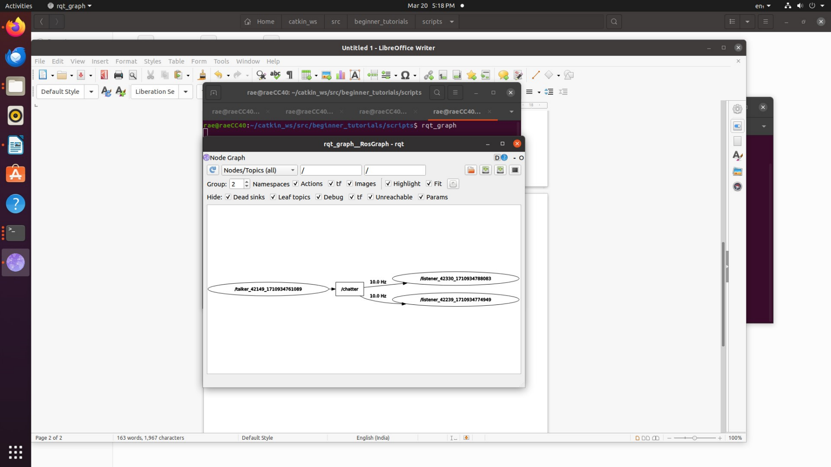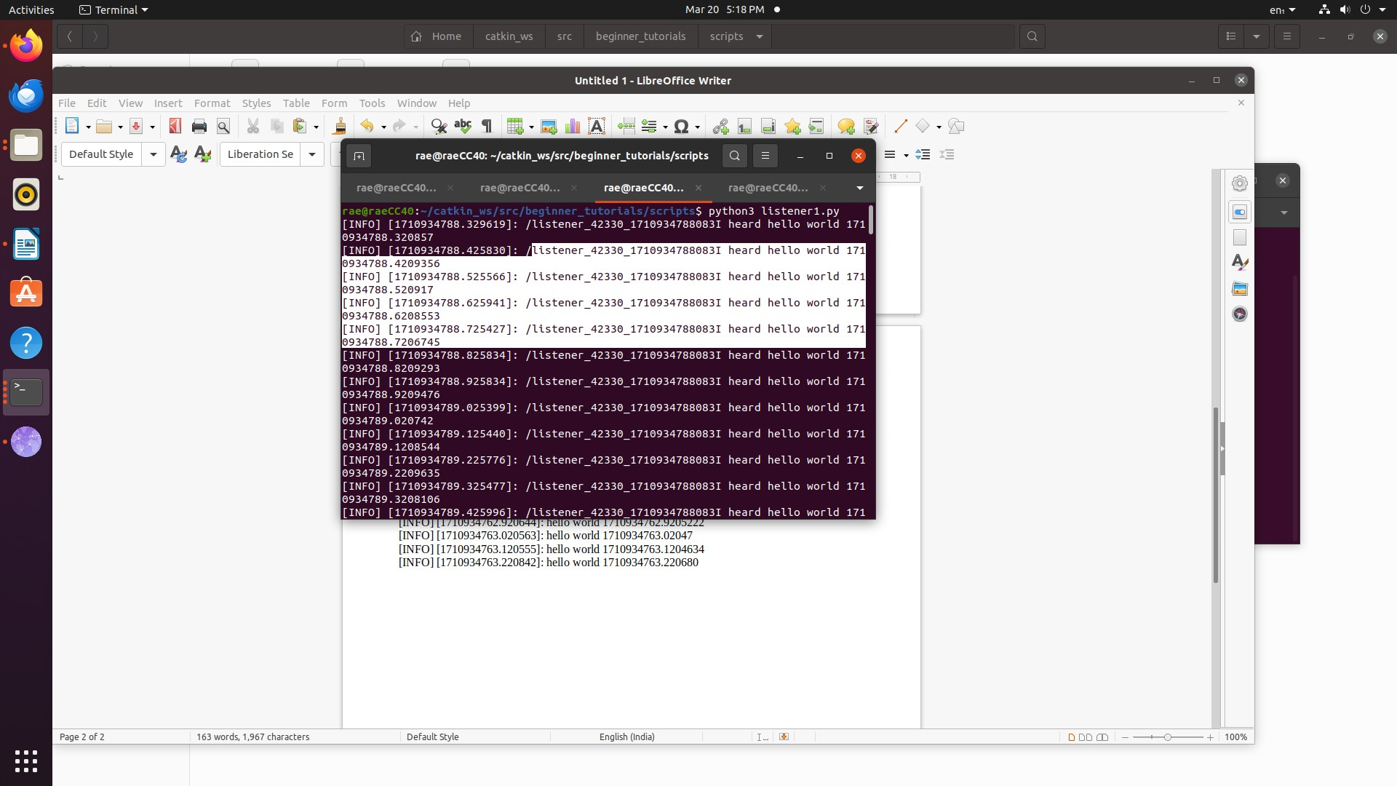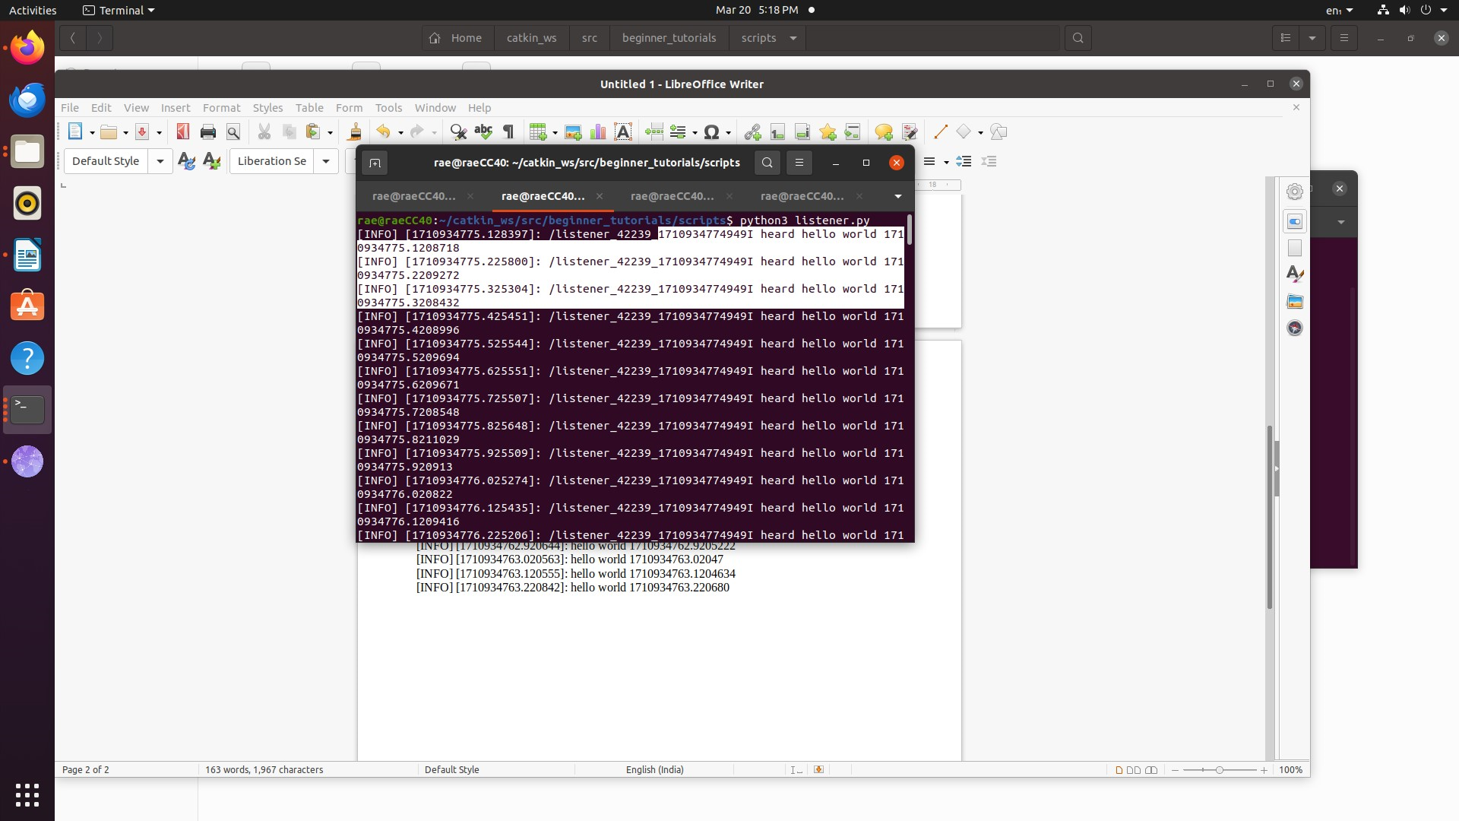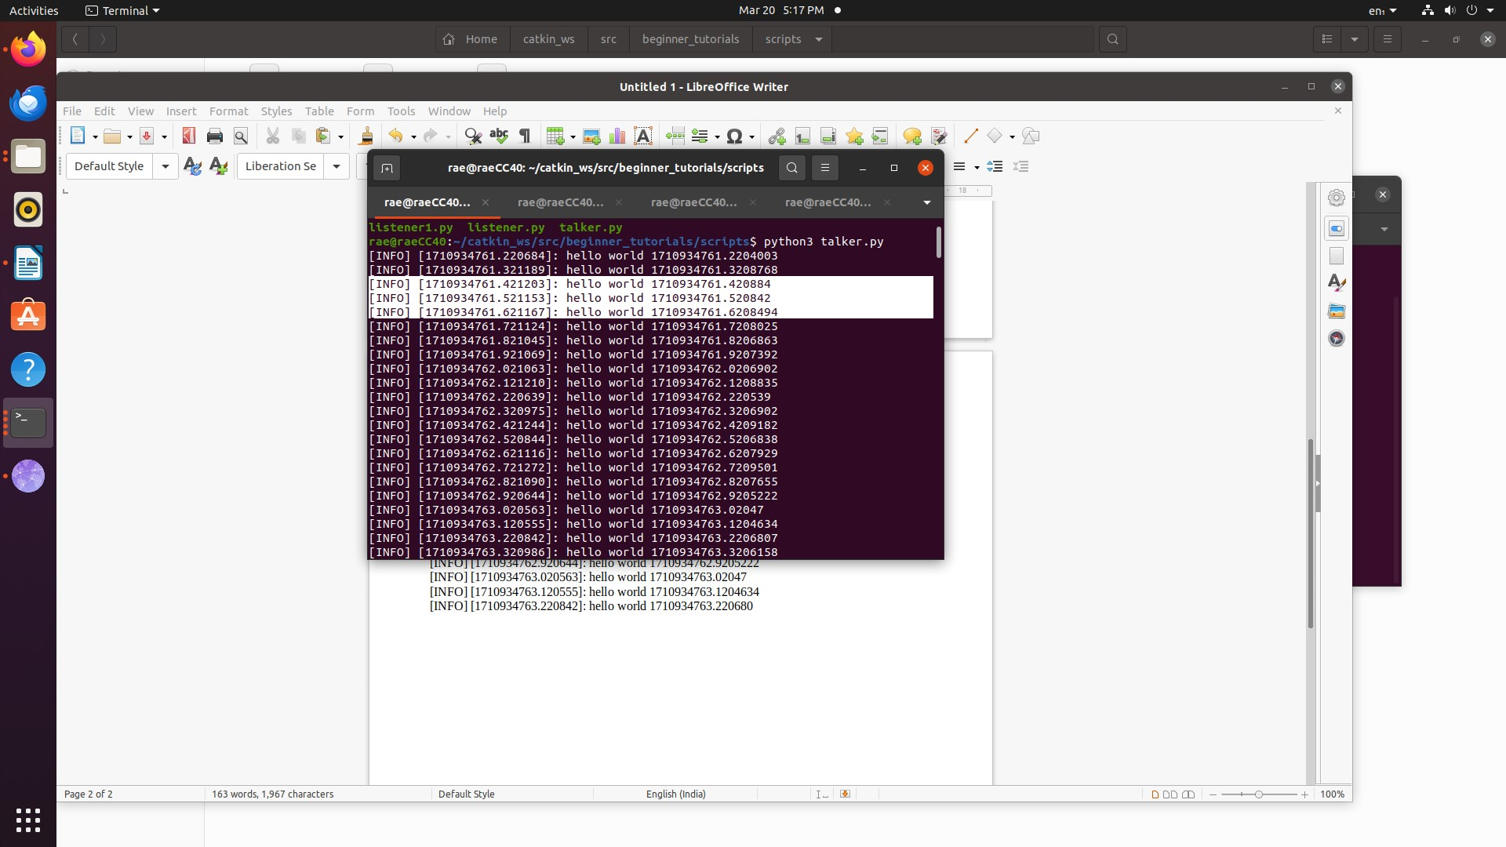**OUTPUT:**

1. **Run turtlesim.**

**COMMANDS:**

● rosrun turtlesim turtlesim_node

● rosrun turtlesim turtle_teleop_key

● rqt_graph

**OUTPUT**

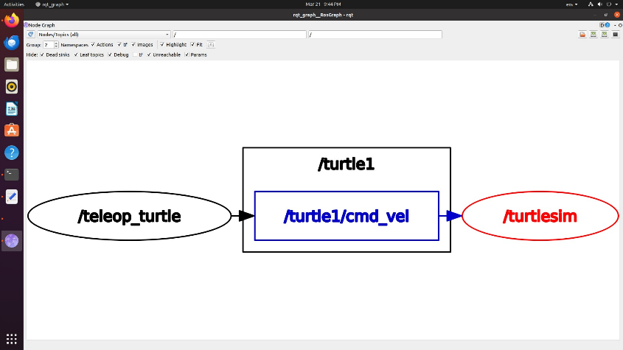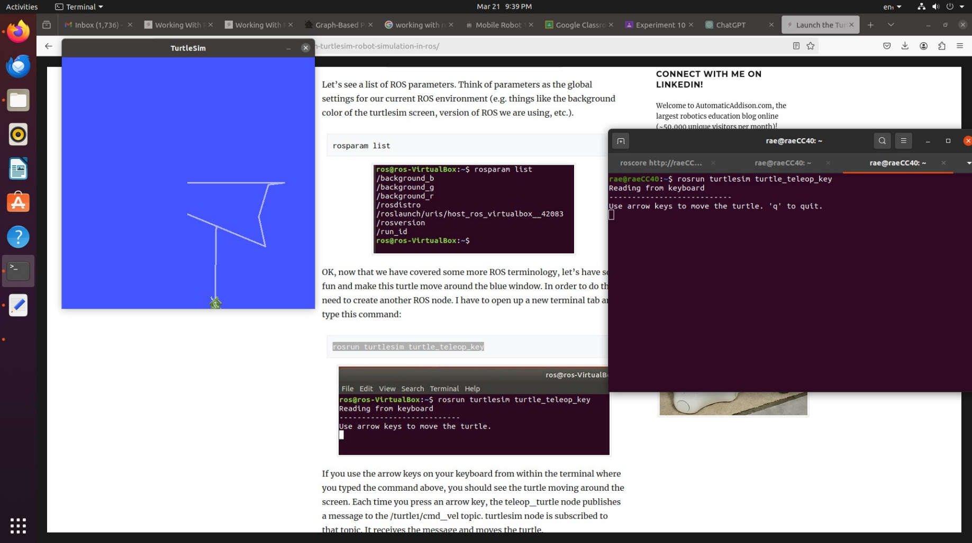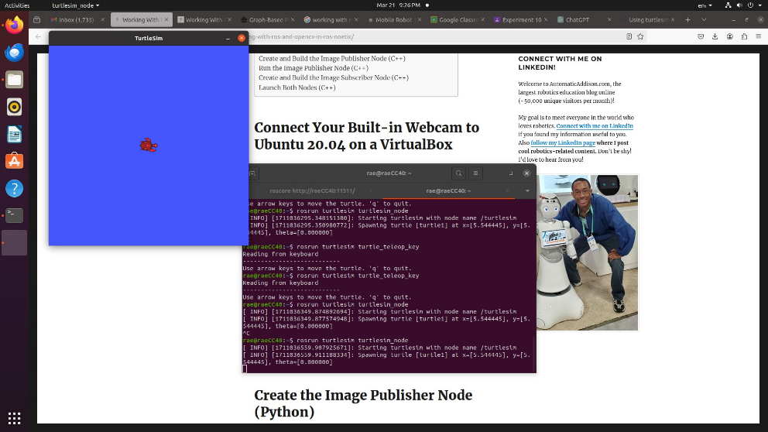

1. **RQT Graph.**

**COMMANDS:**

* rqt_graph

**OUTPUT**

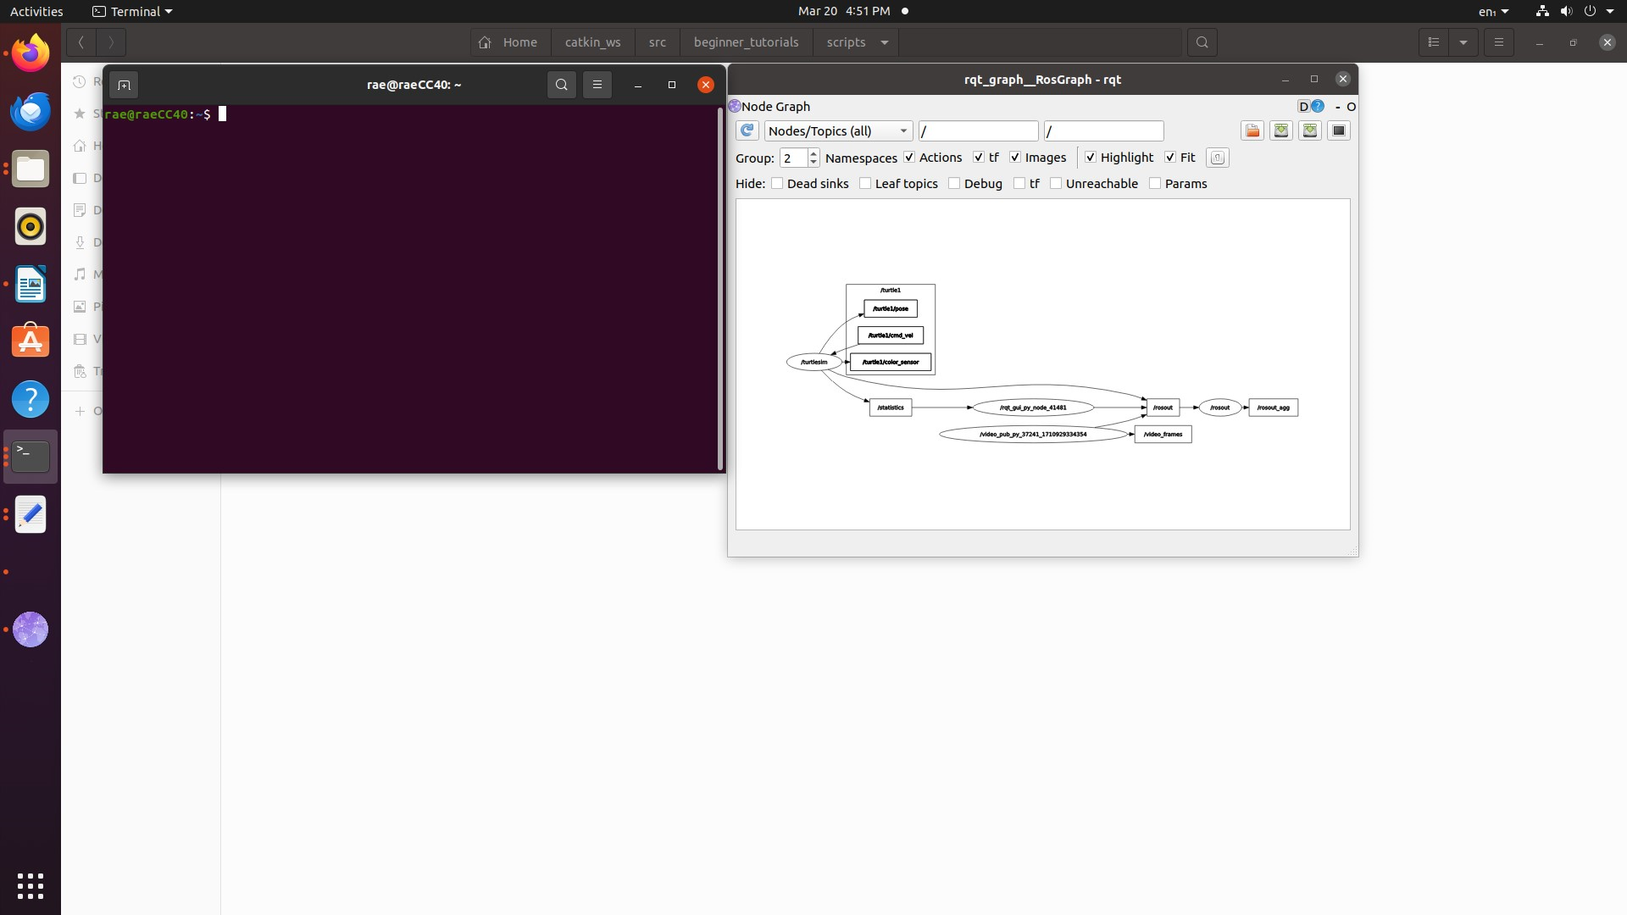

1. **Bridge RoS with openCV. Read an image into RoS and rotate the image.**

**CODE:**

#!/usr/bin/env python3

import rospy # Python library for ROS

from sensor_msgs.msg import Image # Image is the message type

from cv_bridge import CvBridge # Package to convert between ROS and OpenCV Images

import cv2 # OpenCV library

def callback(data):

br = CvBridge()

rospy.loginfo("receiving video frame")

current_frame = br.imgmsg_to_cv2(data)

current_frame=cv2.circle(current_frame,(60,60),10,(0,255,255),-1)

current_frame=cv2.rotate(current_frame,cv2.ROTATE_90_CLOCKWISE)

cv2.imshow("camera", current_frame)

cv2.waitKey(0)

def receive_message():

rospy.init_node('video_sub_py', anonymous=True)

rospy.Subscriber('video_frames', Image, callback)

rospy.spin()

cv2.destroyAllWindows()

if _name_ == '_main_':

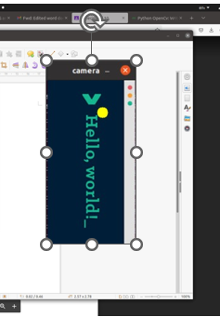 receive_message()

**OUTPUT:**

**5. Read an image into RoS and perform colour conversions on an image.**

**CODE:**

#!/usr/bin/env python3

import rospy # Python library for ROS

from sensor_msgs.msg import Image # Image is the message type

from cv_bridge import CvBridge # Package to convert between ROS and OpenCV Images

import cv2 # OpenCV library

def publish_message():

pub = rospy.Publisher('video_frames', Image, queue_size=10)

rospy.init_node('video_pub_py', anonymous=True)

rate = rospy.Rate(10) # 10hz

cap = cv2.imread('/home/rae/Downloads/test.png',0)

br = CvBridge()

while not rospy.is_shutdown():

if True:

rospy.loginfo('publishing video frame')

pub.publish(br.cv2_to_imgmsg(cap))

rate.sleep()

if _name_ == '_main_':

try:

publish_message()

except rospy.ROSInterruptException:

pass

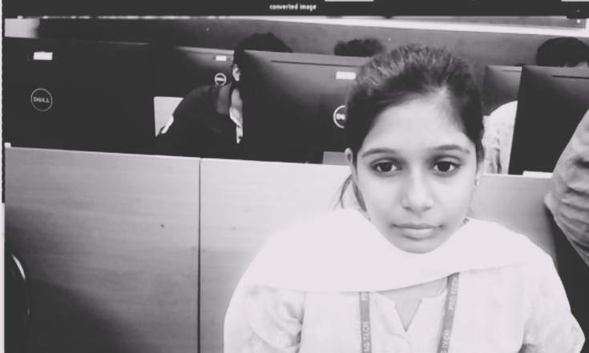**OUTPUT:**

**6.Write AI and vison on an image.**

**CODE:**

#!/usr/bin/env python3

import rospy # Python library for ROS

from sensor_msgs.msg import Image # Image is the message type

from cv_bridge import CvBridge # Package to convert between ROS and OpenCV Images

import cv2 # OpenCV library

def publish_message():

pub = rospy.Publisher('video_frames', Image, queue_size=10)

rospy.init_node('video_pub_py', anonymous=True)

rate = rospy.Rate(10) # 10hz

cap = cv2.imread('/home/rae/Downloads/black screen.png')

current_frame=cv2.putText(current_frame,"AI & VISION",(50,50),cv2.FONT_HERSHEY_SIMPLEX,1,(255,0,255),2,cv2.LINE_AA)

br = CvBridge()

while not rospy.is_shutdown():

if True:

rospy.loginfo('publishing video frame')

pub.publish(br.cv2_to_imgmsg(cap))

rate.sleep()

if _name_ == '_main_':

try:

publish_message()

except rospy.ROSInterruptException:

pass

**OUTPUT:**

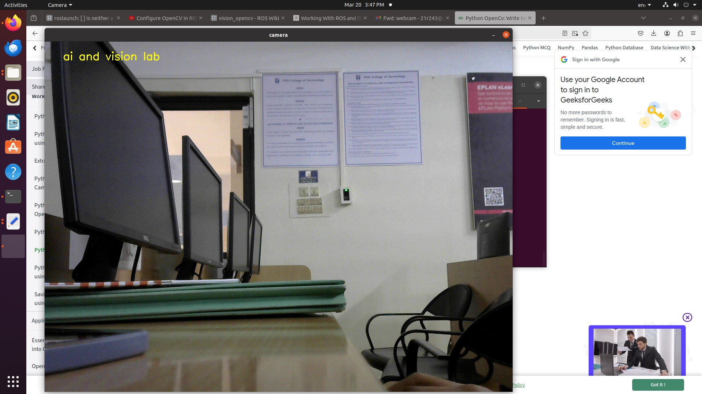

1. **Find the difference between the two images.**

**CODE:**

import rospy # Python library for ROS

from sensor_msgs.msg import Image # Image is the message type

from cv_bridge import CvBridge # Package to convert between ROS and OpenCV Images

import cv2 # OpenCV library

def publish_message():

pub = rospy.Publisher('video_frames', Image, queue_size=10)

rospy.init_node('video_pub_py', anonymous=True)

rate = rospy.Rate(10) # 10hz

cap = cv2.imread('/home/rae/Downloads/test.png',0)

br = CvBridge()

while not rospy.is_shutdown():

rospy.loginfo('publishing video frame')

pub.publish(br.cv2_to_imgmsg(cap))

rate.sleep()

if _name_ == '_main_':

try:

publish_message()

except rospy.ROSInterruptException:

pass

**OUTPUT:**

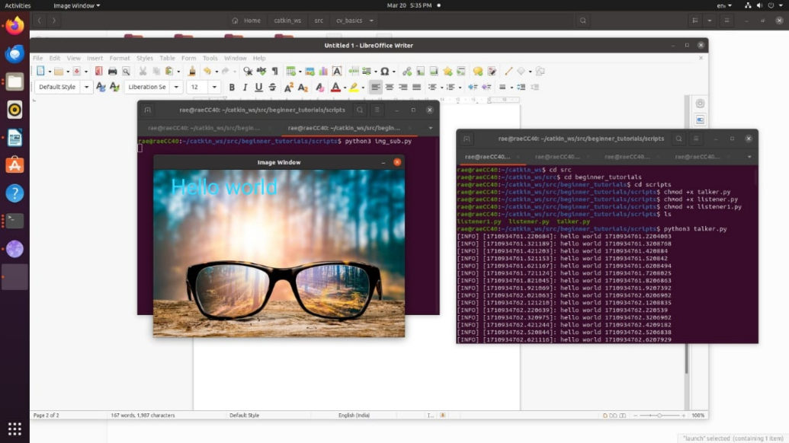

1. **Write a python program in RoS to sort a given set of numbers.**

**CODE:**

#Initialize array

arr = [5, 2, 8, 7, 1];

temp = 0;

#Displaying elements of original array

print("Elements of original array: ");

for i in range(0, len(arr)):

print(arr[i], end=" ");

#Sort the array in ascending order

for i in range(0, len(arr)):

for j in range(i+1, len(arr)):

if(arr[i] > arr[j]):

temp = arr[i];

arr[i] = arr[j];

arr[j] = temp;

print();

#Displaying elements of the array after sorting

print("Elements of array sorted in ascending order: ");

for i in range(0, len(arr)):

print(arr[i], end=" ");

**OUTPUT:**

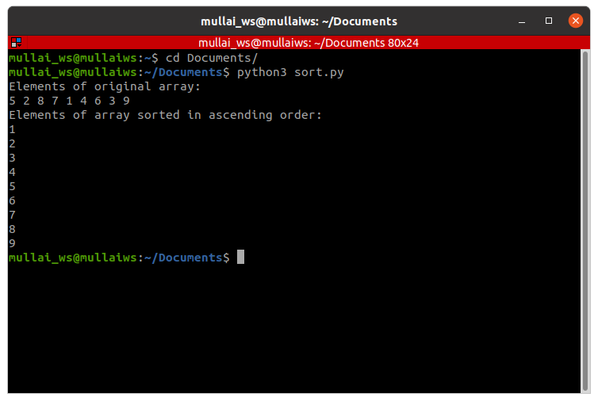

1. **Stream the video from USB camera in RoS and write your name on the stream.**

**CODE:**

#!/usr/bin/env python3

import rospy # Python library for ROS

from sensor_msgs.msg import Image # Image is the message type

from cv_bridge import CvBridge # Package to convert between ROS and OpenCV Images

import cv2 # OpenCV library

def callback(data):

br = CvBridge()

rospy.loginfo("receiving video frame")

current_frame = br.imgmsg_to_cv2(data)

current_frame=cv2.putText(current_frame,"hiiiii",(50,50),cv2.FONT_HERSHEY_SIMPLEX,1,(255,0,255),2,cv2.LINE_AA)

current_frame=cv2.circle(current_frame,(60,60),10,(0,255,255),-1)

cv2.imshow("camera", current_frame)

cv2.waitKey(1)

def receive_message():

rospy.init_node('video_sub_py', anonymous=True)

rospy.Subscriber('video_frames', Image, callback)

rospy.spin()

cv2.destroyAllWindows()

if _name_ == '_main_':

receive_message()

**OUTPUT:**

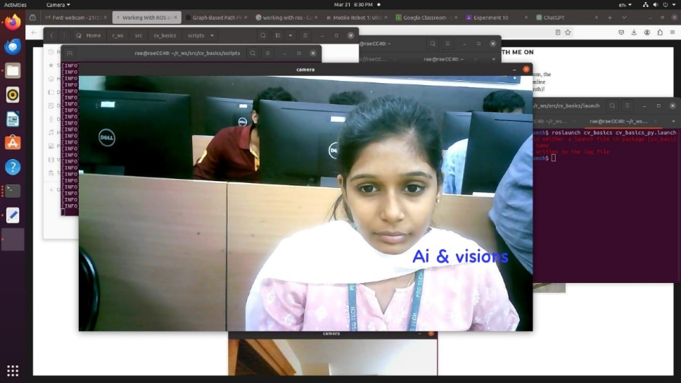

1. **Simulate a world of your own in Gazebo and Rviz and spawn a turtlebot on it.**

**Environment with turtlebot 3 has been setup:**

**SETUP:**

**Download link:**

*https://github.com/SakshayMahna/Robotics-Playground/tree/main/turtlebot3_ws*

**Unzip into home dir.**

Open terminal

roscore

**Open another terminal**

sudo apt-get install ros-noetic-navigation

Open another terminal

cd turtlebot3_ws/

catkin_make

source devel/setup.bash

**TO RUN TURTLEBOT3:**

**Terminal 1**

roscore

**Terminal 2**

cd turtlebot3_ws/

catkin_make

source devel/setup.bash

roslaunch ros_world turtlebot3_world.launch

**Terminal 3**

cd turtlebot3_ws/

catkin_make

source devel/setup.bash

roslaunch global_path_planning turtlebot3_ros_world.launch

**Terminal 4**

cd turtlebot3_ws/

catkin_make

source devel/setup.bash

rosrun global_path_planning path_planning_server.py

**Output:**

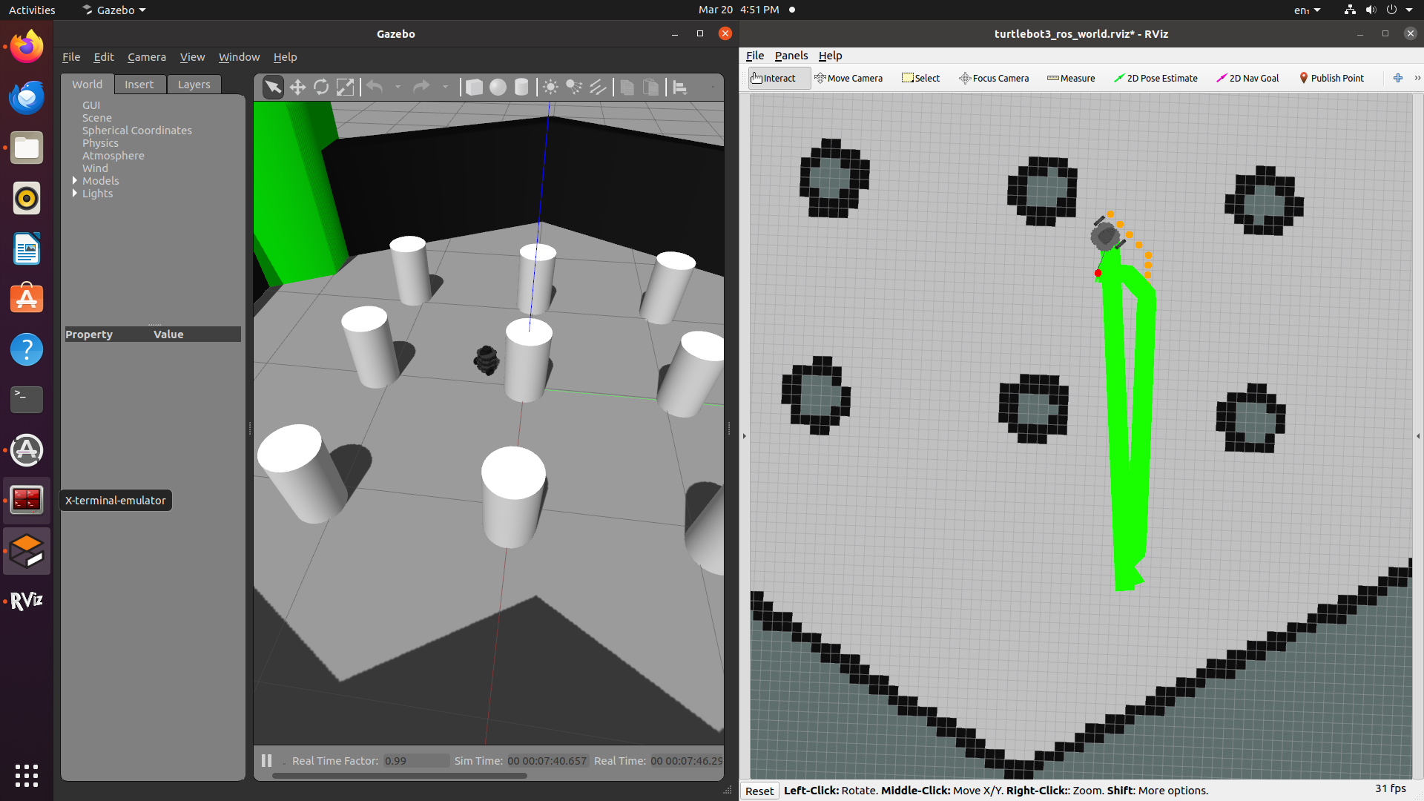

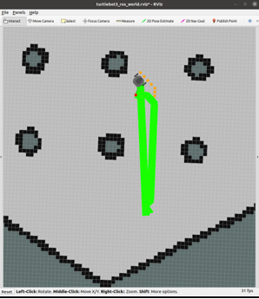

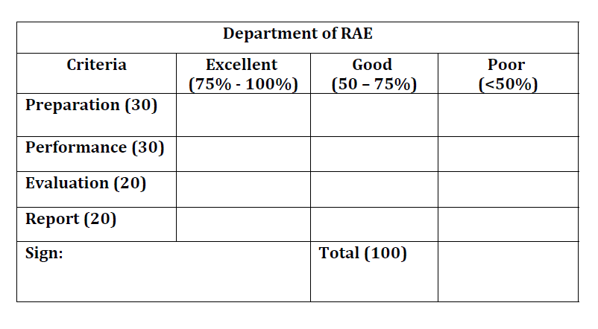

**Result:**

Thus the RoS basics has been successfully implemented.